**LAPORAN USABILITY TESTING**

**SISTEM INFROMASI PERPUSTAKAAN DENGAN LARAVEL**



Laporan Ini Di Susun Untuk Memenuhi Nilai Mata Kuliah Framework Programming Pada Program Studi D IV Teknik Informatika

**Oleh :**

**Nama : Mukhammad Sabda Abdulloh (16090106)**

**PROGRAM STUDI D IV TEKNIK INFORMATIKA**

**POLITEKNIK HARAPAN BERSAMA**

**TEGAL**

**2019**

Perangkat lunak ini adalah sarana untuk peminjaman buku dalam perpustakaan dengan tujuan untuk membuat proses peminjaman buku, pengelolaan dan pelaporan kegiatan di lingkungan perpustakaan menjadi lebih efektif. perangkat lunak ini berkaitan beberapa entitas, yaitu petugas perpustakaan dan pengunjung perpustakaan yang merupakan anggota ataupun bukan.

1. **Pengujian White Box**
2. **Flowchart Diagram**
3. 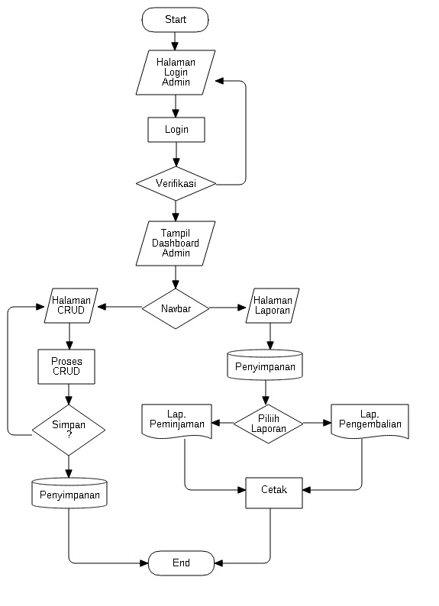**Bagian Admin**

Gambar 1. Flowchart Diagram Bagian Admin

1. 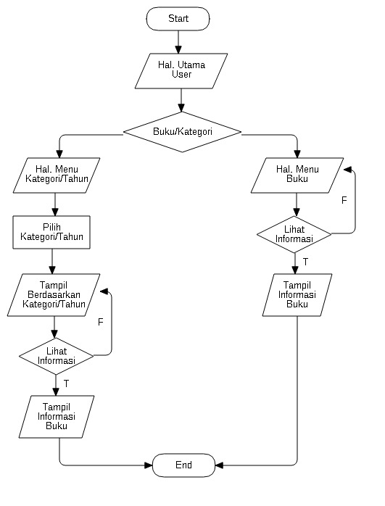**Flowchart User.**

Gambar 2. Flowchart Diagram Bagian User

1. **CFG (Control Flow Graph)**
2. **CFG Admin b. CFG User**

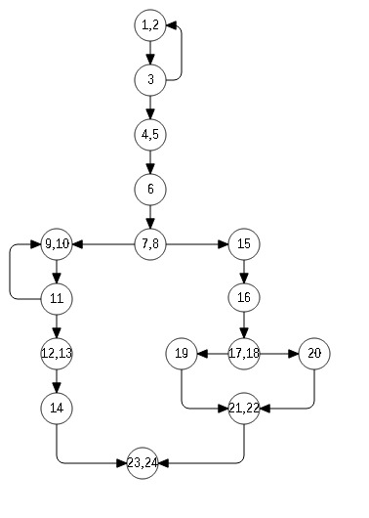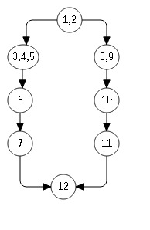

Gamb

Gambar 4. CFG User

Gambar 3. CFG Admin

1. **Cyclomatic Complexity**
2. **Bagian Admin**

= (E – N) + 2 b. = Decision + 1

= (19 - 16) + 2 = 4 + 1

= 5 = 5

1. **Bagian User**

= (E – N) + 2 b. = Decision + 1

= (10 - 9) + 2 = 3+ 1

= 4 = 4

1. **Basic Path**
2. **Bagian Admin**
3. Path 1 = 1 – 2 – 3 – 4 – 5 – 6 – 7 – 8
4. Path 2 = 1 – 2 – 3 – 4 – 5 – 6 – 7 – 8 – 9 – 11 – 10 – 12 – 13 – 14 – 23
5. Path 3 = 1 – 2 – 3 – 4 – 5 – 6- 8 – 15 – 16 – 17 – 18 – 19 – 21 -22 – 24
6. Path 4 = 1 – 2 – 3 – 4 – 5 – 6 – 8 – 15 – 16 – 18 – 20 – 21 – 22 – 23 – 24
7. Path 5 = 1 – 2 – 3 – 4 – 5 – 6 – 7 – 8 – 9 – 10 – 11 – 12 – 13 – 14 – 15 – 16 – 17 – 18 – 19 – 20 – 21 – 22 – 23 – 24
8. **Bagian User**
9. Path 1 = 1 – 2 – 3 – 4 -5 – 6 – 5
10. Path 2 = 1 – 2 – 3 – 4 – 6 – 7 – 12
11. Path 3 = 1 – 8 – 9 – 10 – 11 – 12
12. Path 4 = 1 – 2 – 3 – 4 – 5 – 6 – 7 – 8 – 9 – 10 – 11 – 12
13. **Pengujian BlackBox**

Kita akan menguji sistem menggunakan black box testing dengan teknik boundary value analysis (BVA) dan menggunakan tabel kebenaran.

1. **Boundary Value Analysis (BVA).**

|  |  |  |  |  |
| --- | --- | --- | --- | --- |
| **Nama Kolom** | **Invalid** | **Valid** | **Invalid** | **Valid** |
| Id | 0 Character | 1 Character | 11 Character | 10 Character |
| Name | 0 Character | 1 Character | 21 Character | 20 Character |
| Username | 0 Character | 1 Character | 256 Character | 255 Character |
| Email | 0 Character | 1 Character | 16 Character | 15 Character |
| Password | 0 Character | 1 Character | 256 Character | 255 Character |
| Gambar | 0 Character |  |  |  |
| level | 0 Character | 1 Character |  | Enum |

1. **Tabel Users**
2. **Tabel Anggota**

|  |  |  |  |  |
| --- | --- | --- | --- | --- |
| **Nama Kolom** | **Invalid** | **Valid** | **Invalid** | **Valid** |
| Id | 0 Character | 1 Character | 11 Character | 10 Character |
| User_id | 0 Character | 1 Character | 11 Character | 20 Character |
| Npm | 0 Character | 1 Character | 12 Character | 11 Character |
| Nama | 0 Character | 1 Character | 256 Character | 255 Character |
| Tempat_lahir | 0 Character | 1 Character | 256 Character | 255 Character |
| Tgl_lahir | 0 Character | 8 | 9 | 9 |
| Jk | 0 Character | 2 Character | 3 Character | 2 Character |
| Prodi | 0 Character | 1 Character | 256 Character | 255 Character |

|  |  |  |  |  |
| --- | --- | --- | --- | --- |
| **Nama Kolom** | **Invalid** | **Valid** | **Invalid** | **Valid** |
| Id | 0 Character | 1 | 11 Character | 20 |
| Judul | 0 Character | 1 Character | 256 Character | 10 Character |
| Isbn | 0 Character | 1 Character | 26 Character | 25 Character |
| Pengarang | 0 Character | 1 Character | 256 Character | 255 Character |
| Penerbit | 0 Character | 1 Character | 256 Character | 255 Character |
| Tahun_terbit | 0 Character | 1 Character | 12 Character | 11 Character |
| Jumlah_buku | 0 Character | 1 Character | 12 Character | 11 Character |
| Deskripsi | 0 Character | 1 Character |  |  |
| Lokasi | 0 Character | 1 Character |  |  |
| Cover | 0 Character | 1 Character | 256 Character | 255 Character |

1. **Tabel Buku**
2. **Tabel Transaksi**

|  |  |  |  |  |
| --- | --- | --- | --- | --- |
| **Nama Kolom** | **Invalid** | **Valid** | **Invalid** | **Valid** |
| Id | 0 | 1 | 11 Character | 10 Character |
| Kode_transaksi | 0 Character | 1 Character | 256 Character | 255 Character |
| Anggota_id | 0 Character | 1 Character | 11 Character | 10 Character |
| Buku_id | 0 Character | 1 Character | 11 Character | 10 Character |
| Tgl_pinjam | 0 Character | 8 | 9 | 9 |
| Tgl_kembali | 0 Character | 8 | 9 | 9 |
| Status | 0 Character |  |  |  |
| Ket | 0 Character |  |  |  |

1. **Tabel Kebenaran**
2. **Form Login**

|  |  |  |
| --- | --- | --- |
| **username** | **Password** | **Action** |
| Blank | Blank | No |
| Blank | True | No |
| Blank | False | No |
| False | True | No |
| False | False | No |
| False | True | No |
| True | False | No |
| True | Blank | No |
| True | True | Success |

1. **Form Tambah User**

|  |  |  |  |  |
| --- | --- | --- | --- | --- |
| **Judul** | **Isi** | **Kategori** | **Foto** | **Action** |
| Blank | Blank | Blank | Blank | No |
| Blank | False | False | False | No |
| Blank | True | True | True | No |
| True | True | True | True | Success |
| True | False | False | False | No |
| True | Blank | Blank | Blank | No |
| False | True | True | True | No |
| False | False | False | False | No |
| False | Blank | Blank | Blank | No |
| Blank | Blank | Blank | True | No |
| Blank | Blank | Blank | False | No |

1. **Form Tambah Buku**

|  |  |  |  |  |
| --- | --- | --- | --- | --- |
| **Judul** | **Isi** | **Kategori** | **Foto** | **Action** |
| Blank | Blank | Blank | Blank | No |
| Blank | False | False | False | No |
| Blank | True | True | True | No |
| True | True | True | True | Success |
| True | False | False | False | No |
| True | Blank | Blank | Blank | No |
| False | True | True | True | No |
| False | False | False | False | No |
| False | Blank | Blank | Blank | No |
| Blank | Blank | Blank | True | No |
| Blank | Blank | Blank | False | No |

1. **Form Tambah Transaksi**

|  |  |  |  |  |
| --- | --- | --- | --- | --- |
| **Judul** | **Isi** | **Kategori** | **Foto** | **Action** |
| Blank | Blank | Blank | Blank | No |
| Blank | False | False | False | No |
| Blank | True | True | True | No |
| True | True | True | True | Success |
| True | False | False | False | No |
| True | Blank | Blank | Blank | No |
| False | True | True | True | No |
| False | False | False | False | No |
| False | Blank | Blank | Blank | No |
| Blank | Blank | Blank | True | No |
| Blank | Blank | Blank | False | No |

1. **Pengujian**
2. 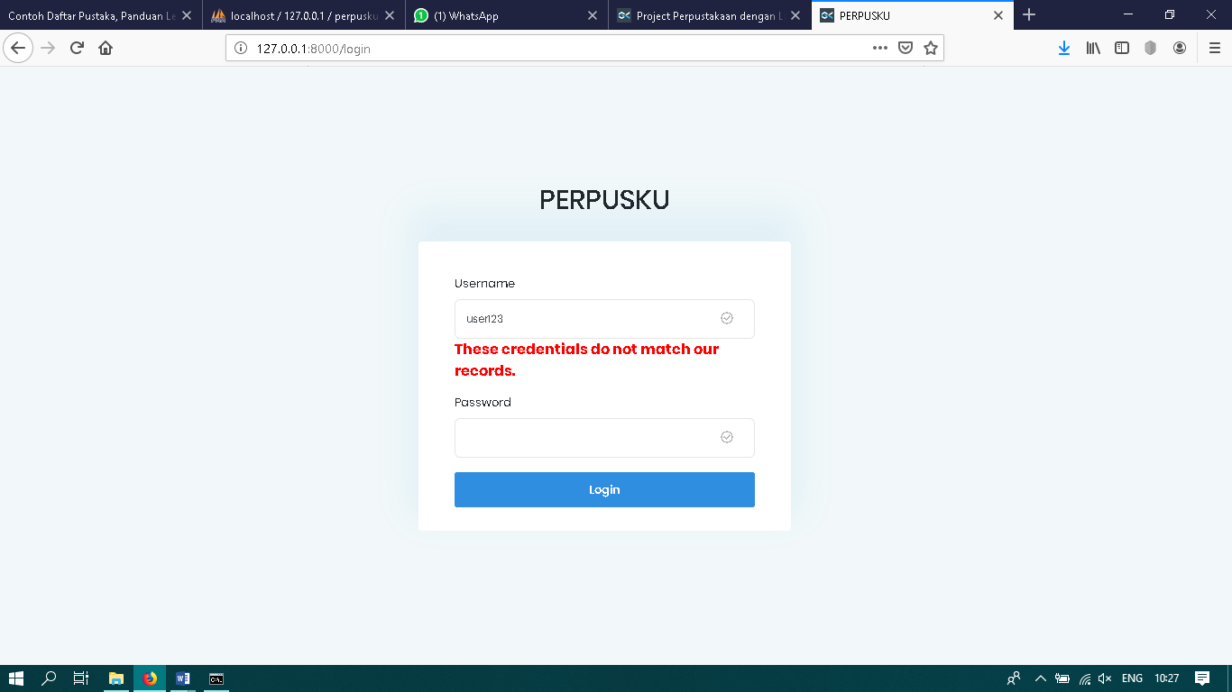**Form Login**

Jika kita akan masuk ke dalam sistem, kita harus login terlebih dahulu baik sebagai seorang user maupun admin. Dan kita harus mengisikan username dan password sesuai dengan record yang ada di database, jika tidak akan muncul pesan error dan tidak bias login ke dalam sistem.

1. **Form Tambah Buku**

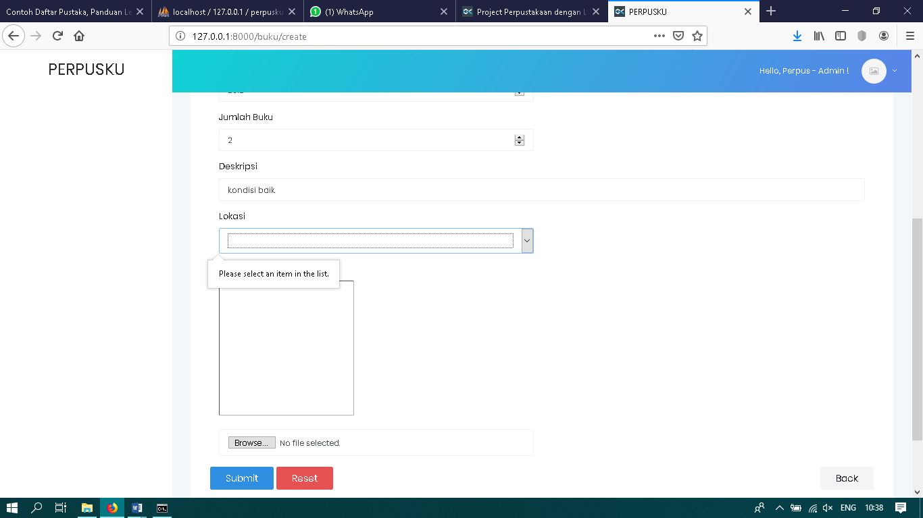

Dalam proses tambah buku, seorang admin juga harus memberikan informasi buku dengan lengkap. Caranya dengan mengisi semua form yang tersedia dengan data yang ada, dan jika ada form yang belum terisi maka data buku tidak bisa di submit dan harus di isi .

1. 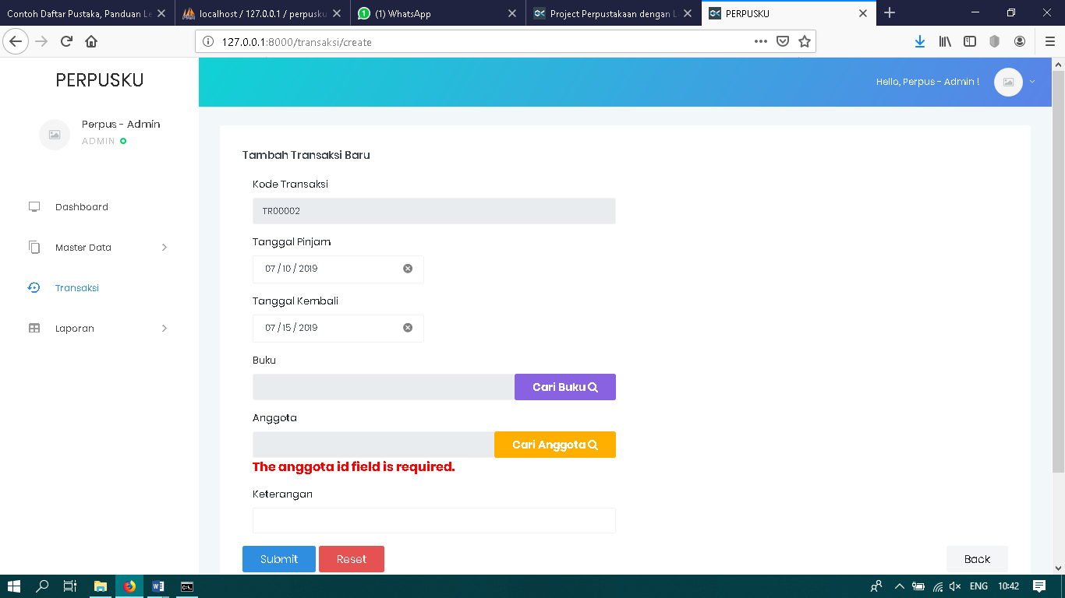**Form Transaksi**

Saat seroang pengunjung akan meminjam buku, admin harus membuat data transaksi peminjaman buku dengan memasukan data ke dalam form yang telah di sediakan. Seperti contoh diatas, jika ada form yang belum di isi, maka transaksi tidak dapat di lakukan dan harus di isi terlebih dahulu.